44-563 Web Services Technology Fall 2010

Exam 1 Version 1

*Questions 1-10 refer to the web page shown below.*

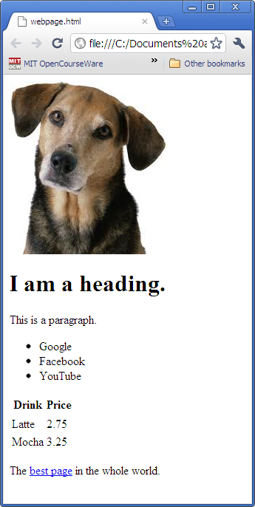

1. (6 pts) Write the HTML code (including the necessary tags) for the heading "I am a heading".

<h1>I am a heading.</h1>

2. (6 pts) Write the HTML code (including the necessary tags) for the paragraph containing the text "This is a paragraph".

<p>

This is a paragraph.

</p>

3. (6 pts) Write the HTML code (including the necessary tags) for the list containing the three items Google, Facebook, and YouTube.

<ul>

<li>Google</li>

<li>Facebook</li>

<li>YouTube</li>

</ul>

4. (6 pts) Write the HTML code (including the necessary tags) for including the picture of a dog in the web page. Assume the name of the picture file is dog.jpg and the file is located in the same directory as the .html file for the web page.

<img src="dog.jpg" alt="A picture of a dog" />

5. (6 pts) Write the HTML code (including the necessary tags) for including the link best page to another web page. Assume the URL of the other page is

http://wonderfulstuff.com/greatpage.html

<a href="http://wonderfulstuff.com/greatpage.html">

best page

</a>

6. (10 pts) Write the HTML code (including the necessary tags) for the table containing information about drinks and their prices. Be sure to include the headings for the columns.

<table>

<thead>

<tr>

<th>Drink</th>

<th>Price</th>

</tr>

</thead>

<tbody>

<tr>

<td>Latte</td>

<td>2.75</td>

</tr>

<tr>

<td>Mocha</td>

<td>3.25</td>

</tr>

</tbody>

</table>

7. (5 pts) Write CSS code to set the background color of the page to yellow.

body {

background-color: yellow;

}

8. (5 ps) Write CSS code to set the color of the heading to red.

h1 {

color: red;

}

9. (5 pts) Write CSS code to put a black border around the paragraph.

p {

border: 1px solid black;

}

10. (5 pts) Write CSS code to display all text in the table (including the column headings) in italics.

table {

font-style: italic;

}

11. (a) (2 pts) Each namespace has a unique URI.

TRUE FALSE

(b) (2 pts) Each namespace has a unique prefix that must be used in all documents that use the namespace.

TRUE FALSE

(c) (2 pts) In the namespace declaration below

**xmlns:ufo="http://www.alienVisitors.org/area51"**

the namespace prefix is ____ufo_______________________________

and the namespace URI is http://www.alienVisitors.org/area51

12. (10 pts) The patients language is defined by this DTD file, named patients.dtd.

**<?xml version="1.0" encoding="UTF-8"?>**

**<!ELEMENT patientList (patient+)>**

**<!ELEMENT patient (age, weight, bloodPressure)>**

**<!ATTLIST patient patientId ID #REQUIRED>**

**<!ELEMENT age (#PCDATA)>**

**<!ELEMENT weight (#PCDATA)>**

**<!ELEMENT bloodPressure (systolic, diastolic)>**

**<!ELEMENT systolic (#PCDATA)>**

**<!ELEMENT diastolic (#PCDATA)>**

Write an XML file patients.xml that uses the patients language to represent the data described below. Your file must validate against the DTD file.

Eve is a patient with id P1234, age 23, weight 128, systolic blood pressure 119, and diastolic blood pressure 76.

<patientList>

<patient patientId="P1234">

<age>23</age>

<weight>128</weight>

<bloodPressure>

<systolic>119</systolic>

<diastolic>76</diastolic>

</bloodPressure>

</patient>

</patientList>13. (12 pts) Answer the questions below concerning this definition from a schema:

**<xsd:complexType name="Items">**

**<xsd:sequence>**

**<xsd:element name="item" minOccurs="1" maxOccurs="4">**

**<xsd:complexType>**

**<xsd:sequence>**

**<xsd:element name="productName" type="xsd:string"/>**

**<xsd:element name="quantity">**

**<xsd:simpleType>**

**<xsd:restriction base="xsd:positiveInteger">**

**<xsd:maxExclusive value="10"/>**

**</xsd:restriction>**

**</xsd:simpleType>**

**</xsd:element>**

**<xsd:element name="USPrice" type="xsd:decimal"/>**

**<xsd:element ref="comment" minOccurs="0"/>**

**<xsd:element name="shipDate" type="xsd:date" minOccurs="0"/>**

**</xsd:sequence>**

**<xsd:attribute name="partNum" type="SKU" use="required"/>**

**</xsd:complexType>**

**</xsd:element>**

**</xsd:sequence>**

**</xsd:complexType>**

**<xsd:simpleType name="SKU">**

**<xsd:restriction base="xsd:string">**

**<xsd:pattern value="\d{2}[A-Z]{3}\d{4}"/>**

**</xsd:restriction>**

**</xsd:simpleType>**

(a) The **item** element can be omitted.

TRUE FALSE

(b) The **item** element can occur 5 times.

TRUE FALSE

(c) The **shipDate** element is required.

TRUE FALSE

(d) The value of **quantity** can be 3.

TRUE FALSE

(e) The maximum legal value of **quantity** is ___9_____.

(f) Give an example of a legal value for **partNum**. 74CAT4912

14. (12 pts) Assume an XML file has the following format:

**<dogList>**

**<dog>**

**<dogName>Tex</dogName>**

**<breed>Standard Poodle</breed>**

**<age>6</age>**

**<owner>**

**<ownerName>**

**<first>Mary</first>**

**<last>Smith</last>**

**</ownerName>**

**<address>**

**<city>Dallas</city>**

**<state>Texas</state>**

**</address>**

**</owner>**

**</dog>**

**REMAINING dog ELEMENTS NOT SHOWN TO SAVE SPACE**

**</dogList>**

We want to use XSL to transform this data into a table in HTML. The table will contain the breed and owner's last name for each dog with an age greater than 2. Write XSL code that produces this table from the data file. **Write ONLY the code that goes between the <table> and </table> tags. Everything else can be omitted.**

NOTE: THERE IS MORE SPACE AVAILABLE ON THE NEXT PAGE

<table>

<xsl:for-each select="dogList/dog">

<xsl:if test="age &gt; 2">

<tr>

<td>

<xsl:value-of select="breed"/>

</td>

<td>

<xsl:value-of select="owner/ownerName/last"/>

</td>

</tr>

</xsl:if>

</xsl:for-each>

</table>

ADDITIONAL SPACE

**DO NOT REMOVE THIS PAGE**

ADDITIONAL SPACE

**DO NOT REMOVE THIS PAGE**